STUDIO
Seats 172 as in picture below
Can reconfigure into various other layouts

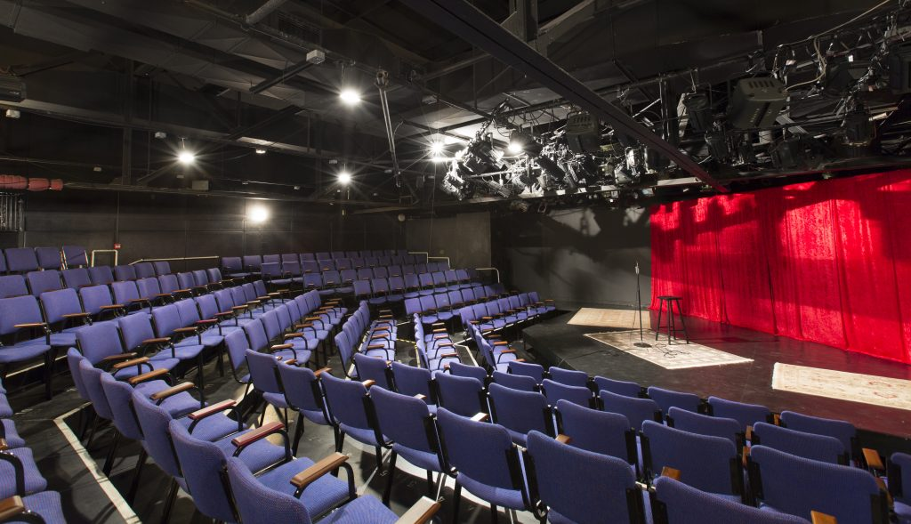

LX
CONTROL
Control is a GrandMA PC on Wing

DIMMERS
Dimmers can be soft patched to you channel allocation. If you choose not to specify channels, dimmer numbers will be used.
60 | STRAND 2kW dimmers

LX EQUIPMENT
Qty | Item | Description | Comment
6 | Selecon Acclaim 650W | 18 – 34 deg zoom profile
6 | Selecon Acclaim 650W | 24 – 44 deg zoom profile
28 | Selecon Acclaim | 650W Fresnel | Barndoors available
8 | Strand Prelude | 650W PC
2 | Strand Prelude | 650W Fresnel
2 | Strand Quartet | 650W PC
2 | Strand Quartet | 650W Fresnel
12 | Strand P743 | 1kW Fresnel
4 | CODA 500 | Flood
 | Parcan | On request | 12 parcans available

ROAMING EFFECTS EQUIPMENT
- 1x MVS Le Maitre Hazers (on request)

SD
CONTROL
12 channel SOUNDCRAFT analogue desk
2x 12inch Yamaha DXR speakers

Roaming SOUND and AV EQUIPMENT
- 4x Tuscan single CD player
- ULX 4 pack receivers for handheld microphones
- ULX 4 pack receivers for lapel microphones
- SLX 2pack receivers for handheld or lapel microphones
- 3x SM58 cabled microphones
- 6x SM57 cabled microphones
- 2x 12 inch YAMAHA DRX monitors/speakers
- 2x 8inch YAMAHA DRX monitors/speakers
- 2x 12 JBL monitors/speakers
- 3x DI boxes
- Necessary cabling
- 2x Mac mini with QLab 3
- 1x Mac book pro QLab 4
- 2x Christie LW551i 5K lumens
- 1x Christie LWU701i 7K lumens

DRESSSING ROOMS
2x four seater rooms

