MAIN THEATRE
674 seats over 3 levels

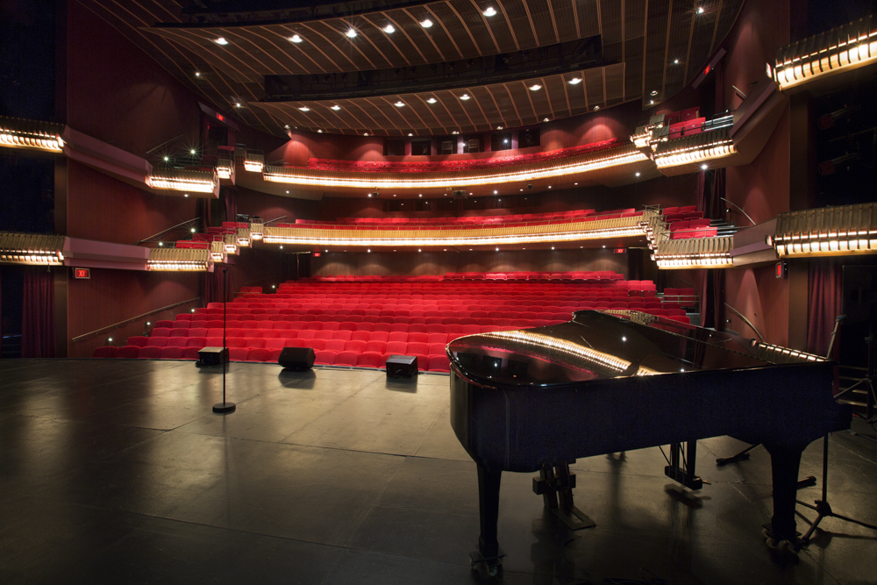

Basic size of the stage
As per plan
LX
CONTROL
Control is a Grand MA Ultra-light DMX 512
DIMMERS
Dimmers can be soft patched to you channel allocation. If you choose not to specify channels, dimmer numbers will be used.
168 | ZERO 88 2 kW Chilli Pro Dimmers
12 | ZERO 88 5 kW Chilli Pro Dimmers
12 | ZERO 88 2 kW

LX EQUIPMENT
Qty | Item | Description | Comment
3 | ETC Source Four 575 W | 5 degree profile
4 | ETC Source Four 575 W | 10 deg profile
28 | ETC Source Four 575 W | 19 deg profile
14 | ETC Source Four 575 W | 26 deg profile
14 | 36 degree | Lens tube
1 | 50 degree | Lens tube
1 | 90 degree | Lens tube
14 | ETC Source Four 575 W | 15 – 30 deg zoom profile
14 | ETC Source Four 575 W | 25 – 50 deg zoom profile
10 | Selecon Arena | 2 kW fresnel
6 | Strand Alto | 2 kW fresnel | Gel burners
20 | Selecon Rama | 1 kW fresnel | 10 barndoors
20 | Selecon Rama | 1 kW PC | 10 barndoors
3 | Strand Coda 1000 | 1 kW flood
50 | PARCAN 1kW | Mostly CP62
14 | 26 Degree lens tube
2 | ROBERT JULIAT 1200W HMI | FOLLOWSPOT

The following items are subject to availability
Qty | Item | Description | Comment
5 | MARTIN MAC 700 | PROFILE
2 | MARTIN MAC 700 | WASH
4 | ROBE 600 WASH | WASH LED
5 | Spiiders | WASH LED

ROAMING EFFECTS EQUIPMENT
- 2x MVS Le Maitre Hazers

SD
CONTROL
Control is a 16 or 32 channel Sound Craft digital desk.
- 2x 12inch Yamaha DXR speakers on perch levels
- 2x 10inch Yamaha DXR speakers on centre cluster
- 2x 18 inch JBL subwoofers next to 12inch on perch level

Roaming SOUND
- 4x Tuscan single CD player
- ULX 4 pack receivers for handheld microphones
- ULX 4 pack receivers for lapel microphones
- SLX 2pack receivers for handheld or lapel microphones
- 3x SM58 cabled microphones
- 6x SM57 cabled microphones
- 2x 12 inch YAMAHA DRX monitors/speakers
- 2x 8inch YAMAHA DRX monitors/speakers
- 2x 12 JBL monitors/speakers
- 3x DI boxes
- Necessary cabling

AV EQUIPMENT
- 1x Christie LW551i 5K lumens
- 1x Christie LWU701i 7K lumens

STAGE EQUIPMENT
1x Brown baby grand piano
1x Upright piano

CURTAINS
1x set black velvet surround
1x black sharkstooth gauze
1x grey back projection screen

RUN OF PLAY
To below dressing rooms and greenroom.

DRESSING ROOMS
2x 2 seaters
2x 3 seaters
2x 5 seaters
2x 15 seaters

GREENROOM
Currently under upgrading.

