FLIPSIDE
Uses the stage of the Theatre, with the audience sitting in the rear stage area, 224 seats

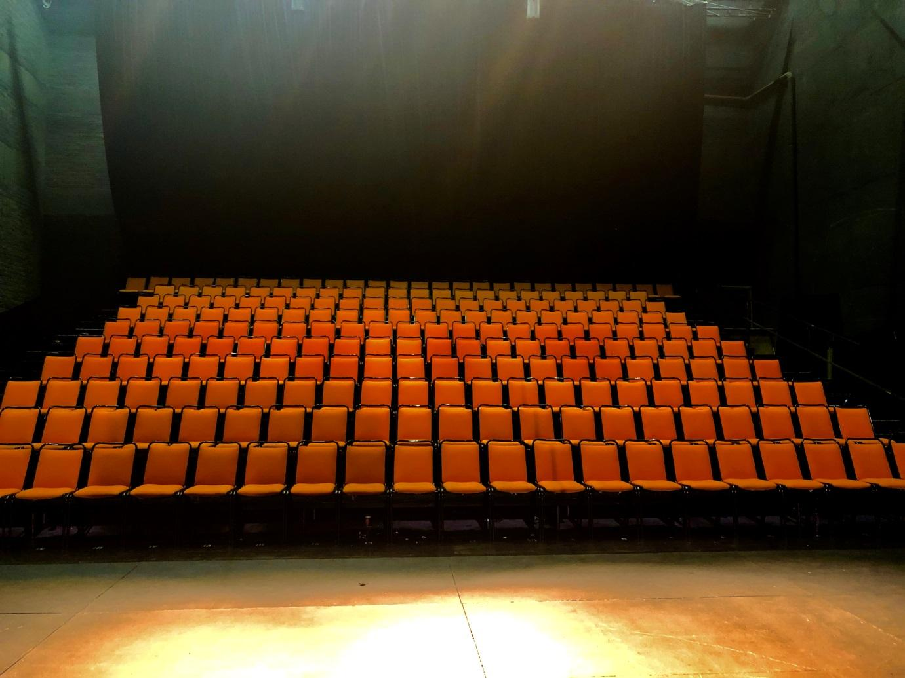

Most of the equipment gets shared between the Main Theatre and Flipside.
LX
CONTROL
Control is a Grand MA Ultra-light DMX 512 or a ETC Geo @5
DIMMERS
Dimmers can be soft patched to you channel allocation. If you choose not to specify channels, dimmer numbers will be used.
100 | ZERO 88 2 kW Chilli Pro Dimmers
12 | ZERO 88 5 kW Chilli Pro Dimmers

LX EQUIPMENT
Qty | Item | Description | Comment
3 | ETC Source Four 575 W | 5 degree profile
4 | ETC Source Four 575 W | 10 deg profile
28 | ETC Source Four 575 W | 19 deg profile
14 | ETC Source Four 575 W | 28 deg profile
14 | 36 degree | Lens tube
1 | 50 degree | Lens tube
1 | 90 degree | Lens tube
14 | ETC Source Four 575 W | 15 – 30 deg zoom profile
14 | ETC Source Four 575 W | 25 – 50 deg zoom profile
10 | Selecon Arena | 2 kW fresnel
8 | Strand Alto | 2 kW fresnel | Gel burners
20 | Selecon Rama | 1 kW fresnel | 10 barndoors
20 | Selecon Rama | 1 kW PC | 10 barndoors
6 | Strand Coda 1000 | 1 kW flood
50 | PARCAN 1kW | Mostly CP62
14 | 26 Degree lens tube
2 | ROBERT JULIAT 1200W HMI | FOLLOWSPOT

The following items are subject to availability
Qty | Item | Description | Comment
5 | MARTIN MAC 700 | PROFILE
2 | MARTIN MAC 700 | WASH
5 | ROBE SPIDERS | WASH

ROAMING EFFECTS EQUIPMENT
- 2x MVS Le Maitre Hazers
SD
CONTROL
Soundcraft LX 7 Analogue desk
2x 12inch Yamaha DXR speakers

Roaming SOUND and AV EQUIPMENT
- 4x Tuscan single CD player
- ULX 4 pack receivers for handheld microphones
- ULX 4 pack receivers for lapel microphones
- SLX 2pack receivers for handheld or lapel microphones
- 3x SM58 cabled microphones
- 6x SM57 cabled microphones
- 2x 12 inch YAMAHA DRX monitors/speakers
- 2x 8inch YAMAHA DRX monitors/speakers
- 2x 12 JBL monitors/speakers
- 3x DI boxes
- Necessary cabling
- 2x Mac mini with QLab 3
- 1x Mac book pro QLab 4
- 2x Christie LW551i 5K lumens
- 1x Christie LWU701i 7K lumens

STAGE EQUIPMENT
1x Brown baby grand piano
1x Upright piano

CURTAINS
1x set black velvet surround
1x black sharkstooth gauze
1x grey back projection screen
RUN OF PLAY
To all dressing rooms

DRESSING ROOMS –shared with the Main Theatre and Concert Hall
2x 2 seaters
2x 3 seaters
2x 5 seaters
2x 15 seaters

GREENROOM
Currently under upgrading (shared with the Main Theatre)

