CONCERT HALL
Seats 638

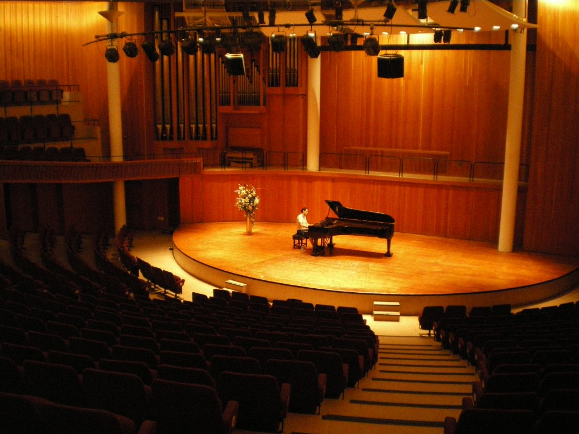

Basic size of the stage
Non symmetrical half circle stage with the most straight upstage measurement of +/- 14,4 m across and upstage centre to downstage centre 7,7m.
For further measurements please refer to the scale on the plan.
LX
CONTROL
Control is a Grand MA Ultra-light DMX 512
DIMMERS
Dimmers can be soft patched to you channel allocation. If you choose not to specify channels, dimmer numbers will be used.
60 | STRAND 2kW dimmers

LX EQUIPMENT
Qty | Item | Description | Comment
15 | ETC Source Four 575 W | 25 – 50 deg zoom profile | Mostly on FOH bar
3 | ETC Source Four 575 W | 10 deg profile | Gallery ring
3 | ETC Source Four 575 W | 5 deg profile | Gallery ring
8 | Selecon Rama PC | 1kW PC | Bars above stage
12 | Strand Parcan | Parcan with CP 62 | 6 each both sides
2 | Robert Juliat Korrigan | HMI Follow spots | Gallery ring

The following items are subject to availability
Qty | Item | Description | Comment
5 | MARTIN MAC 700 | PROFILE
2 | MARTIN MAC 700 | WASH
2 | ROBE ROBIN 600E | PROFILE
4 | ROBE 600 LED | WASH

ROAMING EFFECTS EQUIPMENT
- 2x MVS Le Maitre Hazers

SD
CONTROL
Control is a 16 or 32 channel Sound Craft digital desk.
3x 12inch Yamaha DXR speakers
1x camera feed for monitor in foyer with sound
Roaming SOUND and AV EQUIPMENT
- 4x Tuscan single CD player
- ULX 4 pack receivers for handheld microphones
- ULX 4 pack receivers for lapel microphones
- SLX 2pack receivers for handheld or lapel microphones
- 3x SM58 cabled microphones
- 6x SM57 cabled microphones
- 2x 12 inch YAMAHA DRX monitors/speakers
- 2x 8inch YAMAHA DRX monitors/speakers
- 2x 12 JBL monitors/speakers
- 3x DI boxes
- Necessary cabling
AV EQUIPMENT
- 1x Christie LW551i 5K lumens
STAGE EQUIPMENT
1x Black Steinway Grand piano
1x Von Beckerath Organ

CURTAINS
- 1x set black curtains for the back of the stage
DRESSING ROOMS –shared with the Main Theatre and subject to availability
- 2x 2 seaters
- 2x 3 seaters
- 2x 5 seaters
- 2x 15 seaters

ORCHESTRA ASSEMBLY ROOM
As holding area.

